**University Database Systems**

**Project**

**Part A**

1. **ER-Diagram for University Database, Using Cardinality and Modality using Crow’s foot notation.**

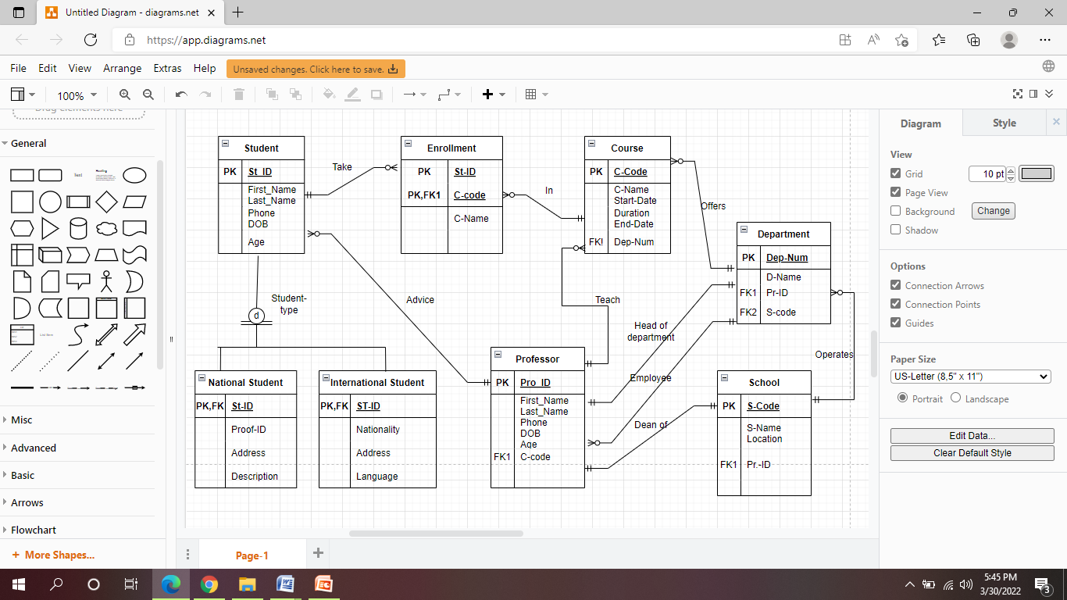

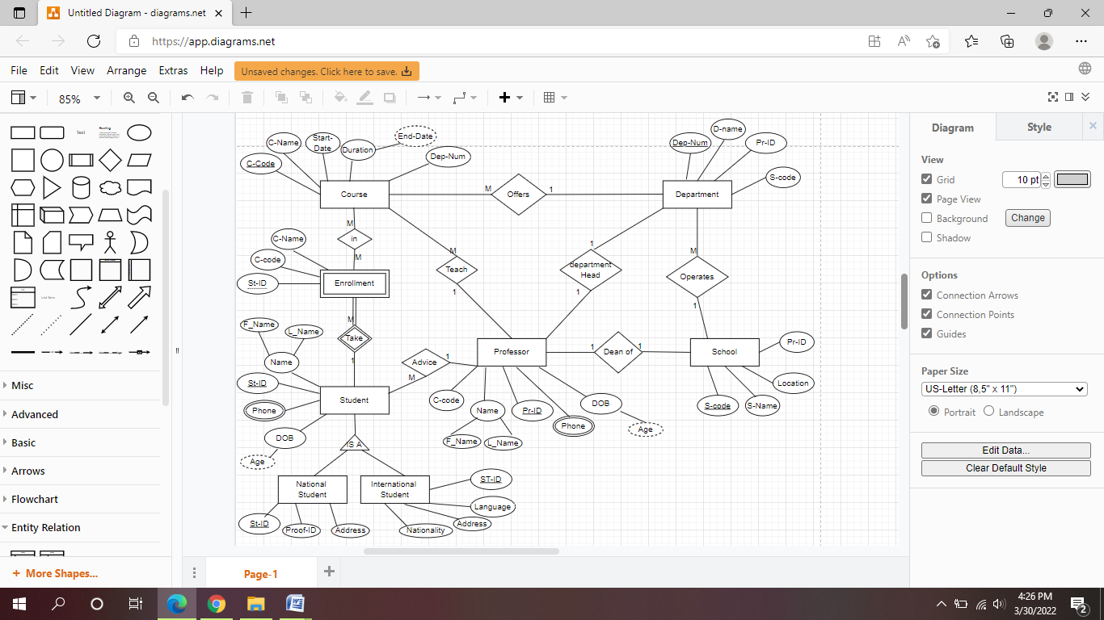

**Part B**

1. **Table Regions**

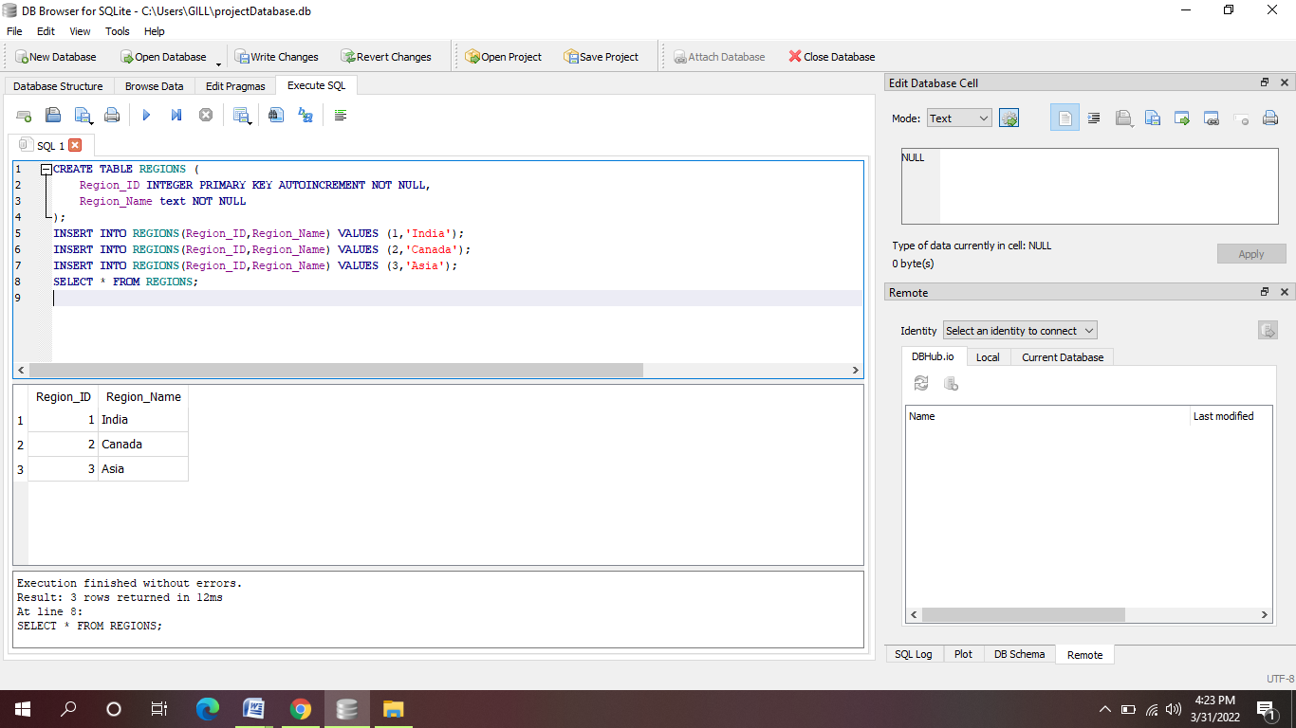

1. **Table Countries**

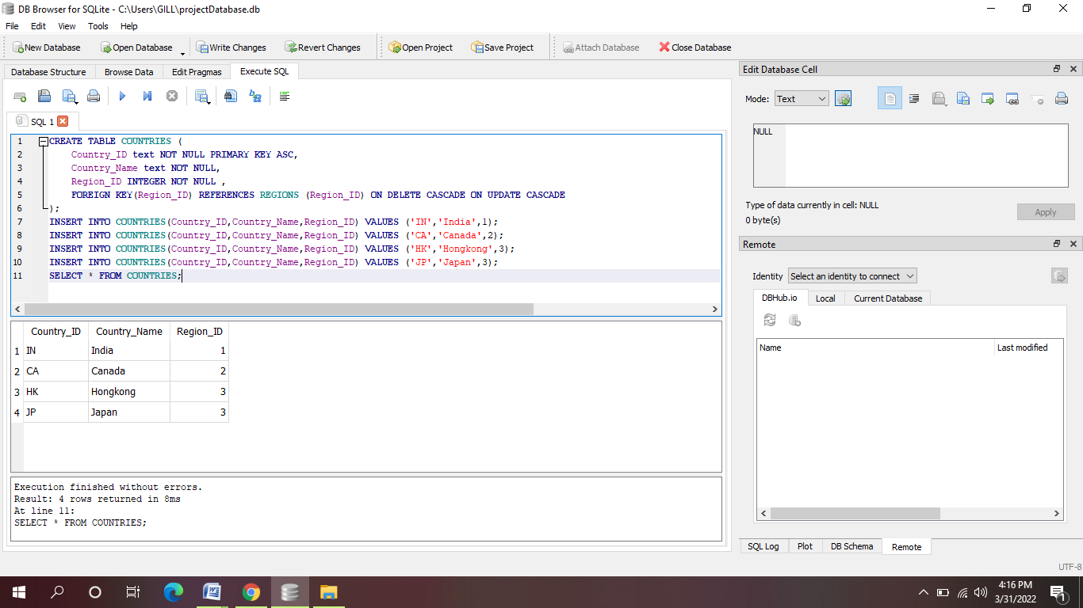

1. **Table Locations**

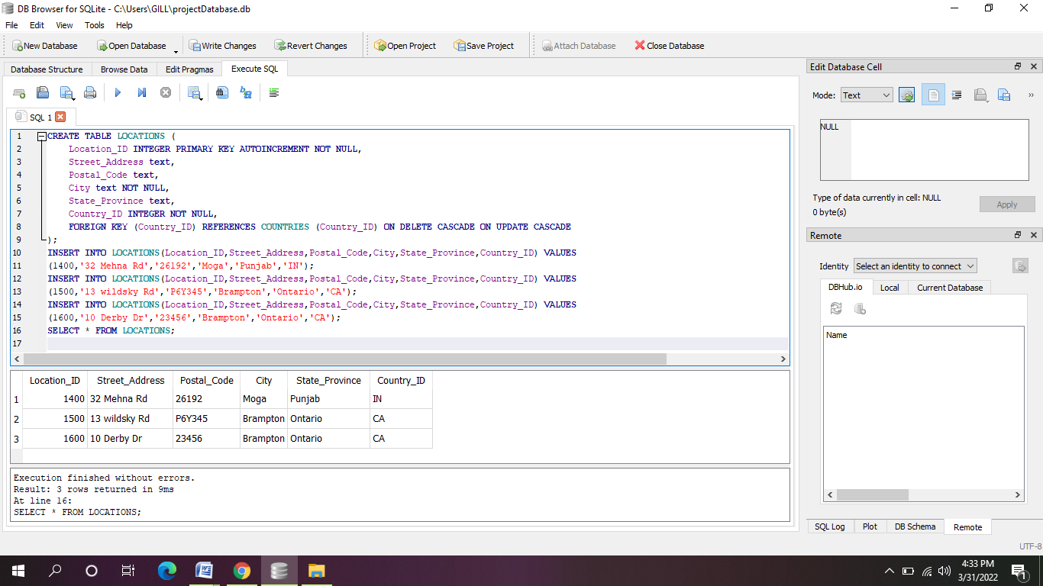

1. **Departments**

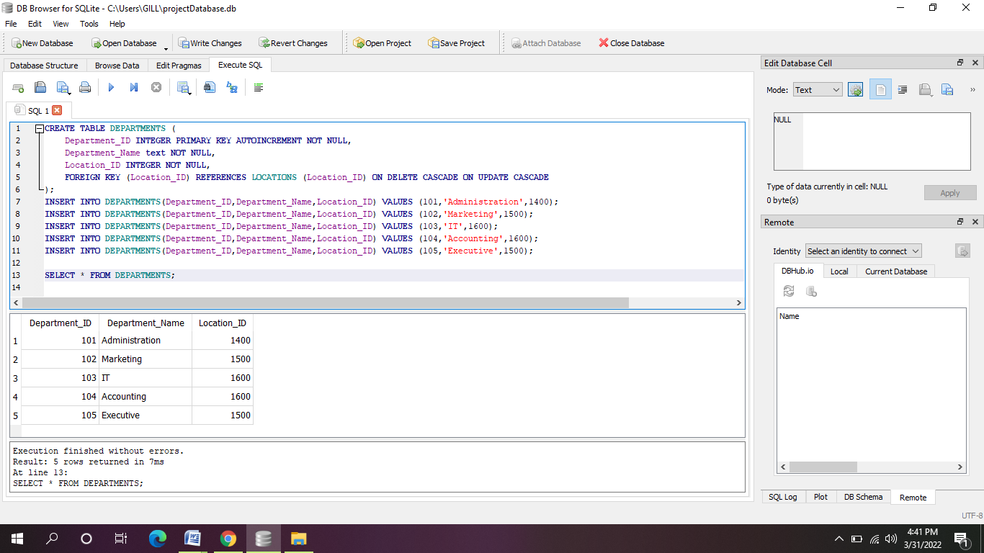

1. **Table Jobs:**

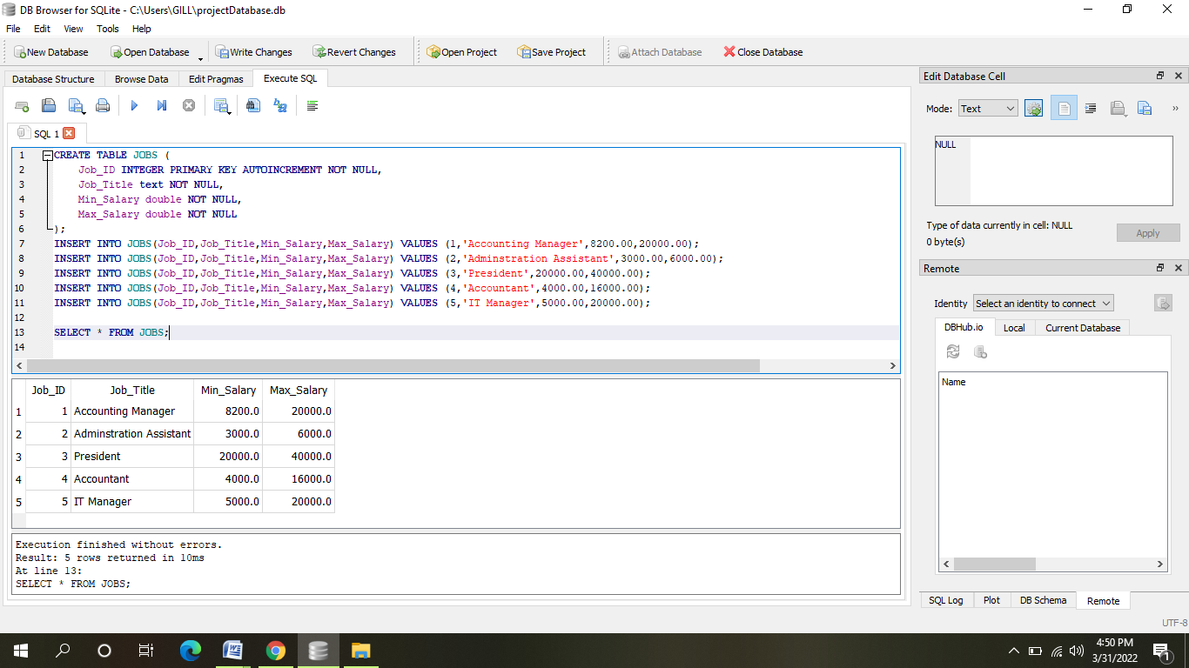

1. **Table Employees**

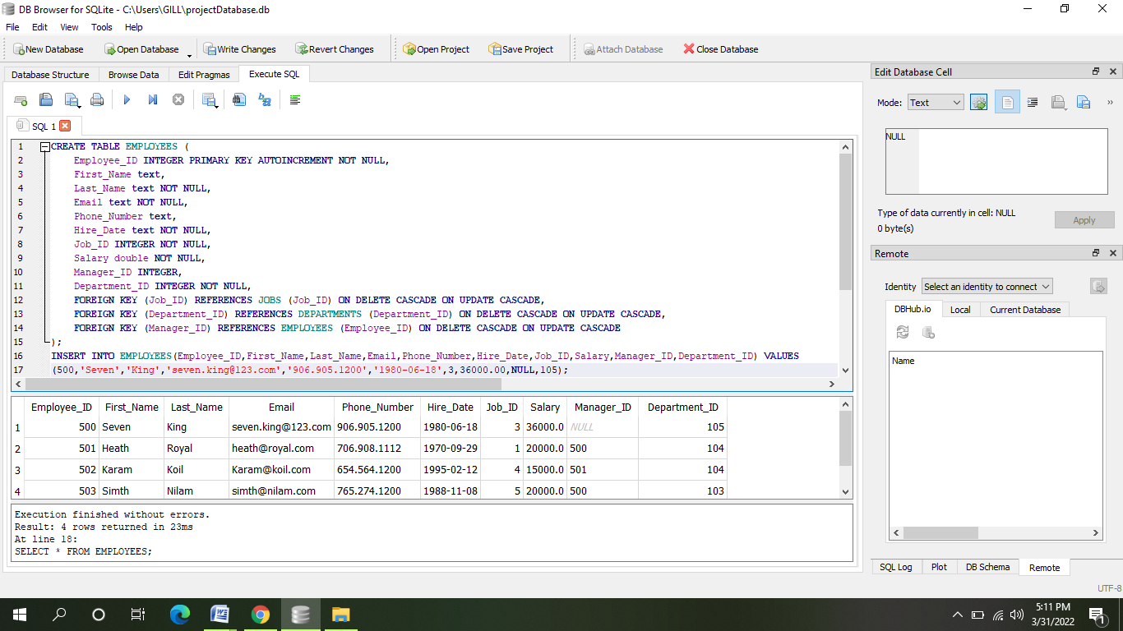

1. **Table Dependents:**

